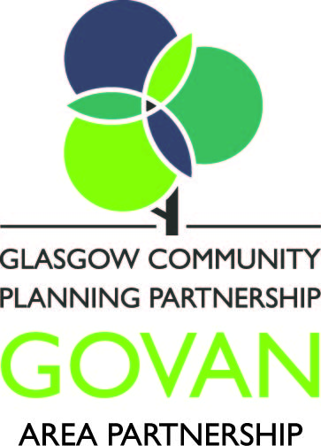 | Corporate Services  Partnership & Development South  Glasgow City Council  Room 15, Adelphi Centre  12 Commercial Road  Glasgow  G5 0PQ

5 December 2016 | Phone: 0141-276-9880  Fax: 0141-276-9889

Dear sir/madam

Glasgow Community Budgeting

Govan Area Partnership Invites You To Send Us Your Project Idea

Glasgow City Council is committed to the promotion of Community Budgeting. This is a process by which the public are encouraged to participate in decision making. Details on this are provided at the end of this letter.

I am writing to you to invite you to consider sending us a project proposal which would be of benefit to the local communities in the Govan area. The Govan Area Partnership and partners have allocated £25,000 to run a community budgeting process from November 2016-January 2017.

The Area Partnership is now inviting bids from community and voluntary organisations which:

- operate and provide services within its boundary area i.e. within Govan Ward 05;
- agree to participate in a Community Budgeting Event by submitting their Funding Proposal and presenting (in any way they choose) their proposal for a share of this £25,000;
- Meet the basic criteria for an Area Grant and
- Can be delivered by end March 2017

I hope that you will consider this opportunity. If you feel that you can do this, please complete and return the attached Govan Community Budgeting Funding Proposal form to patricia.mcmahon2@glasgow.gov.uk, no later than Monday 9th January 2017 for it to be considered. Your Community Budgeting Event will be held on Wednesday 25th January 2017 from 6-8:30pm in Clyde Community Hall, 41 Whitefield Road, Glasgow, G51 2YB.

Guidance on completion of the form is attached but if you have any queries, please contact Yvonne Reilly on 0141 276 9880 for clarification or further information.

Community and voluntary organisations whose proposals meet the eligibility criteria will be notified and invited to present their proposal at the Community Budgeting Event, and the decision on which community and voluntary organisations are awarded funding will be made by the local community attending the event above.

I provide some background below on community budgeting for your information. Meanwhile, I hope you will participate in the allocation of this £25,000 in the Govan Ward.

Yours sincerely

Bailie Fariha Thomas
Chair of the Govan Area Partnership

Background to Community Budgeting

Glasgow City Council’s Strategic Plan for 2012 -2017 states that “part of our approach to community planning and devolving responsibility for how services are developed locally, we will roll out community budgeting to local areas so local people have greater influence over, and input into, how services are developed and delivered.”

Community Budgeting (CB) is a generic term which covers a range of initiatives and approaches, and one of the most common approaches to CB is known as ‘Participatory Budgeting’. Participatory budgeting is a democratic process in which community members decide how to spend part of a public budget and is described in the following terms:

“Participatory budgeting directly involves local people in making decisions on the spending priorities for a defined public budget. This means engaging residents and community groups representative of all parts of the community to discuss spending priorities, making specific proposals and voting on them, as well as giving local people a role in the scrutiny and monitoring process.”

